 

INSTITUTE FOR ADVANCED

COMPUTING AND

SOFTWARE DEVELOPMENT

AKURDI, PUNE

Documentation On

COACHING INSTITUTE MANAGEMENT SYSTEM PG-DAC

SEPTEMBER 2021

Submitted by – Group No 86

-Rajeev Swarnakar (219138)

-Rishikesh Turkar(219144)

Centre Coordinator :- Prashant Karhale Sir.

Project Guide – Milind Arjun Sir.

Project Mentor – Mrs. Monica Jadhav

# Table of Contents

1. INTRODUCTION
2. OBJECTIVE(PURPOSE)
3. PROBLEM STATEMENT
4. SCOPE
5. USERS
6. FUNCTIONAL AND NON-FUNCTIONAL REQUIREMENTS
7. UML DIAGRAMS

* PAGE FLOW DIAGRAMS
* ER DIAGRAM
* DATA FLOW DIAGRAM

1. SPECIFICATIONS
2. HARDWARE AND SOFTWARE USED
3. DATABASE TABLES

INTRODUCTION

Coaching Institute management software is a complete solution for managing an administration. In other words an enhanced tool that assists in organizing the day-to-day activities of the coaching institutes. Coaching institute management system centralizes institute by providing features to its Administration, Students, Staffs. The attendance review shows all students, staffs absent today and click on student's name to see information detail . Administrators are provided with a full control over this software. Students are provided with user ids and password. Students can access their full details regarding marks, attendance, mock test, faculty, course, subject. This system provides a simple interface for the maintenance of student and staff information. It can be used by coaching educational institutes to maintain the records of students easily.

**Objective (Purpose):**

This software helps **manage Student, Faculty, Courses, Attendance, and Marks**. The software guarantees saving of money and time for owners apart from organizing the institute information. You can streamline the coaching institute business.

**To lessen the gap in communication**

* As we have seen, parent-teacher meetings are organized to conduct the parents communication with the parents so that they can know about their kids performance and other activities. But these meetings are not daily basis, so the parents dont have a clear idea about the performance of their kids and are unaware of their growth. Here institute management software works as a bridge between the teachers, students, and parents through instant warning, and notification.
* **Manage Online Education**
* This software helps **manage Student, Faculty, Courses, Attendance, and Notes**. The software guarantees saving of money and time for owners apart from organizing the institute information. You can streamline the coaching institute business.
* To provide a proper registration channel/system to the new students .
* To maintain all the accounts of the students in digital form from enrollment upto the end of the study.
* To make the information accessible to the admin at the desk, in just a click away.
* To have a centralized control over the records of the students, staffs and monitor changes in these records.

## Problem Statement

In the existing systems all the work is done manually and all the data is stored by using files and registers. The record of every student, courses, teachers are handled manually. If we want to access any student information then all the details can not received in one file only. There is need to search lots of records and files registers. In current mode of working first all the information is received and then fill up in the registers. If we want to check any student details like update or delete information it is very difficult to search all records also it is very time wasting process

**Scope:**

This project deals with the various functioning in Coaching Institute management process. The main **idea is to implement a proper process to system**. In our existing system contains a many operations registration, student search, fees, attendance, exam records, performance of the student etc.

USERS :

* visitors
* students
* faculties
* admin
* **Requirements:**
* Functional Requirements:

This section provides requirement overview of the system.

* + 1. **Student Login**
    2. **Faculty Login**
    3. **Admin Login**

1. **Student**

* Recorded Session => Student will be able to access recorded lectures uploaded by faculties.
* Notes => Student will get the access to the notes prepare by faculty every day as uploaded by the faculty.
* Test (page) => Student will be provided a regular mock test after completion of the topic and its scores will be display into the result as checked by the faculty.
* Schedule=> Student will be able see the time table prepared by the admin.
* Attendance Details=> Student will be to see their attendance in the class and what topics they have missed in the course.
* Personal Details => Student will be able to save and edit some details like phone number email id etc.
* Course Details => Student will be able to see the syllabus of the course and important topics in the course.
* Change Password=> Student will be able to change the password of their account.

1. **Faculty**

* Course => Faculty can see the assigned courses to them.
* Attendance Marking => Faculty can mark student present or absent.
* Faculty will be able to upload Notes for the student.
* Faculty will be able to upload Time Table For Student.
* Create Test =>Faculty can create mock test for the students.
* Upgrade Course Details => Faculty will be able to request admin to add or remove some topics from the syllabus.
* Change Password=> Faculty will be able to change the password of their account.

1. **Admin (can access all records of student and faculty)**

* Student attendance report=> Admin will be able to see the attendance of the students.
* Faculty attendance report=> Admin will be able to see the attendance of the faculties.
* Access to users of the website=>Admin will be able to provide access or deny access to the student or the faculty.
* Can perform CRUD operation of users=>Admin will be able to add or remove the access of the user.
* Can Edit the Courses offered by the Institute => Admin can add or remove courses offered by institute and can also make changes in the syllabus of the course.

Admin can also change the faculty for the assigned course.

* Controls of what to display on login page=> Admin will be able to change the displays in the main page of the portal.
* Test=>Admin will be able to add and edit test.

Non-functional Requirement:

* Security
  + - Registered User will allowed to access portals facilities.
    - Each user will be able to access system through authentication process. Who are you?
    - System will provide access to the content, operations using Role based security (Authorization) (Permissions based on Role)
* Reliability
* The system will backup business data on regular basis and recover in short time duration to keep system operational
* Continuous updates are maintained, continuous Administration is done to keep system operational.
* During peak hours system will maintain same user experience by managing load balancing .
* Availability
  + - Uptime: 24* 7 available
    - 99.999%
* Maintainability:
  + - A Commercial database software will be used to maintain System data Persistence.
    - A readymade Web Server will be installed to host online coaching Portal (Web Site) to management server capabilities.
    - IT operations team will easily monitor and configure System using Administrative tools provided by Servers.
    - Separate environment will be maintained for system for isolation in production, testing, and development.
* Portability:
  + - PDA: Portable Device Application
    - System will provide portable User Interface (HTML, CSS, and JS) through users will be able to access online coaching portal.
    - System can be deployed to single server, multi-server, to any OS, Cloud (Azure or AWS or GCP)
* Accessibility:
  + - Only registered user will be able to access the facilities after authentication.
    - Admin User can change the permission state from yes to no based on role provided.
    - Admin User will be able to view daily, weekly, monthly, annual progress through customized dashboard.
* Durability:
  + - System will retain registered user session for 15 minutes even though registered user loose internet connection and join again.
    - System will maintain record of students’ progress. Student will be able to ask questions and share questions among the users.
    - System will implement backup and recovery for retaining registered users data and the progress made by the user.
* Efficiency:
  + - On exam weeks, maximum number of users will access, view with same response time.
* Modularity:
  + - System will designed and developed using reusable, independent or dependent business scenarios in the form of modules.
    - These modules will be loosely coupled and highly cohesive.
    - System will contain URM, membership and Roles management modules.
* Scalability:
  + - System will be able to provide consistent user experience to registered user as well as visitors irrespective of load.
* Safety:
  + - Coaching Institute Portal will be secure from malicious attack, fishing.
    - Coaching Institute Portal functionalities are protected from outside with proper firewall configuration.
    - Coaching Institute Portal will be always kept updated with latest anti-virus software.
    - Users’ data will be backed up periodically to ensure safety of data using incremental back up strategy.
    - Role based security will be applied for Application data and operations accessibility.

Use Case Diagram: ( UML)

* + - Object Oriented Analysis and Design Notation: UML--------Unified Modelling language
    - Design Phase:
      * Activity diagram
      * Data Flow Diagram
      * Class diagram
      * Page flow Diagram

***Page Flow Diagrams***

ADMIN FLOW

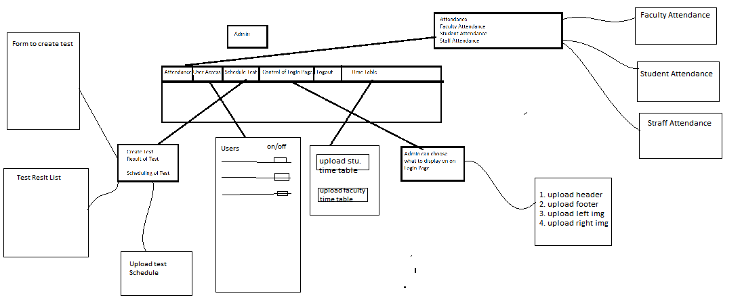

STUDENT FLOW

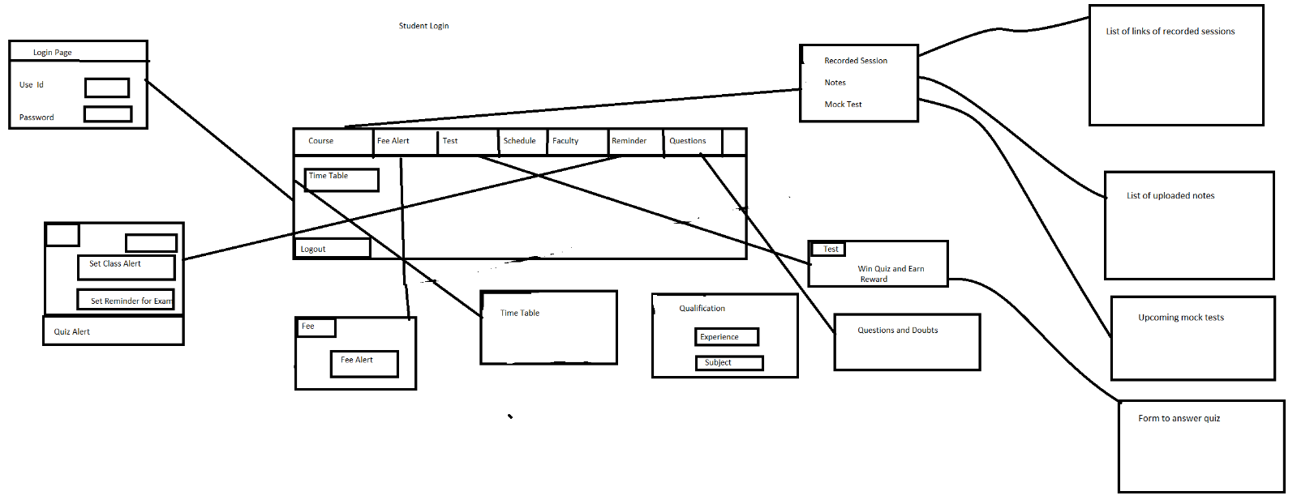

FACULTY FLOW

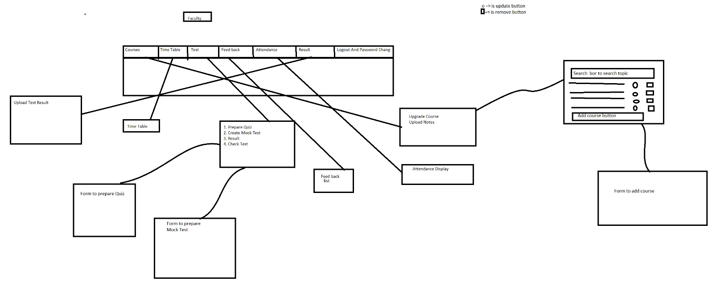 ***E-R Diagram***

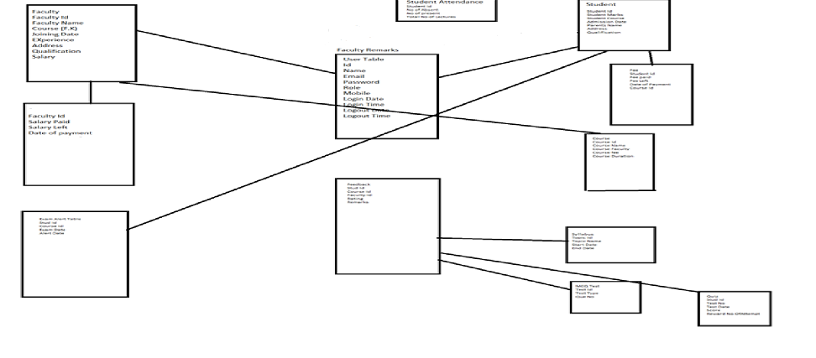

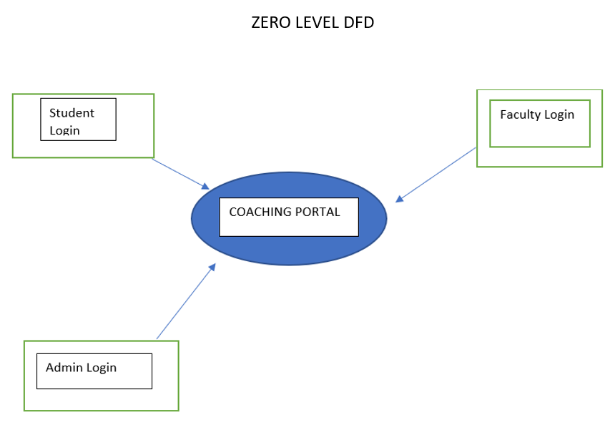

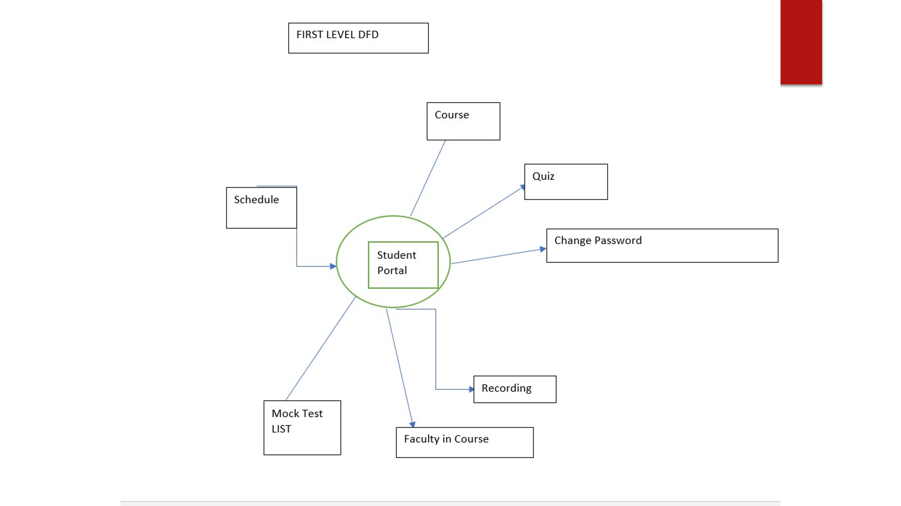

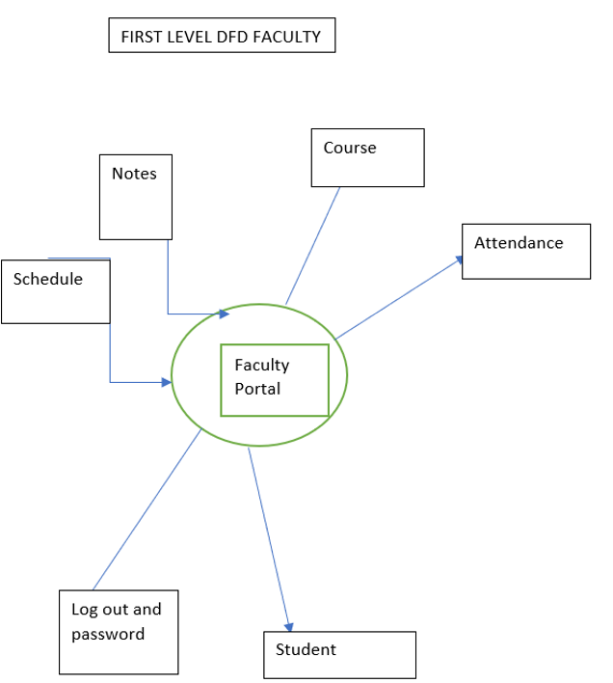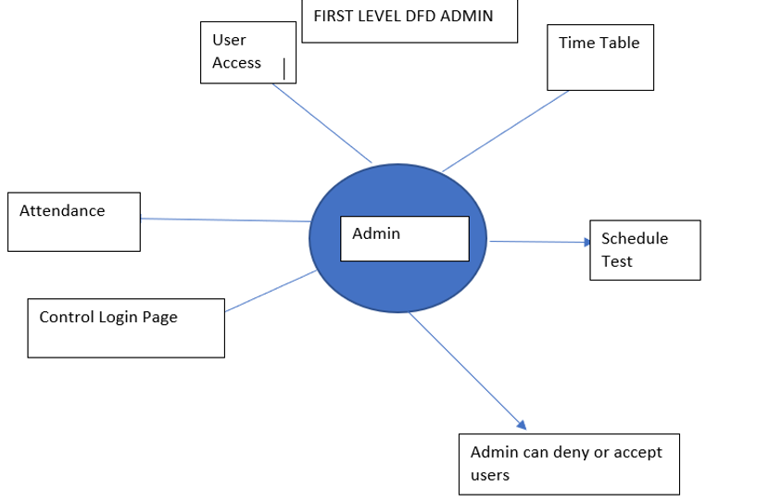

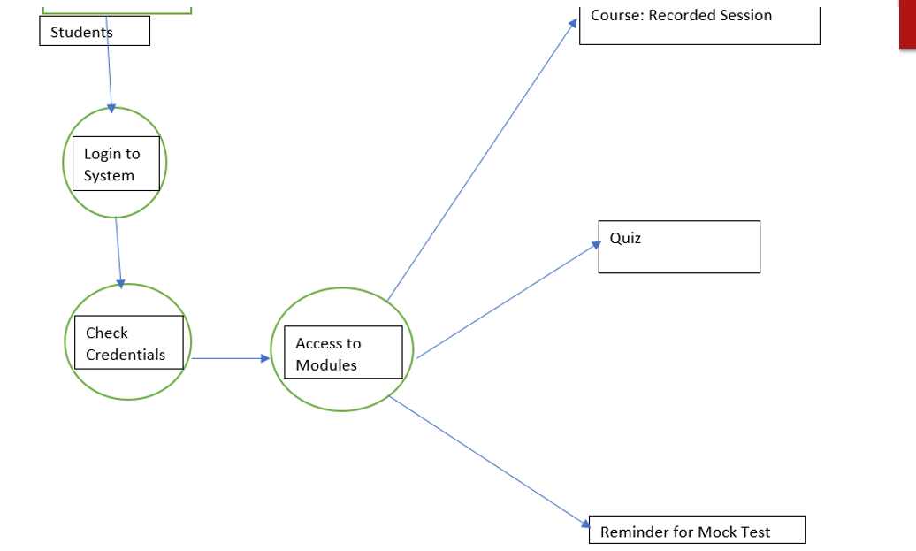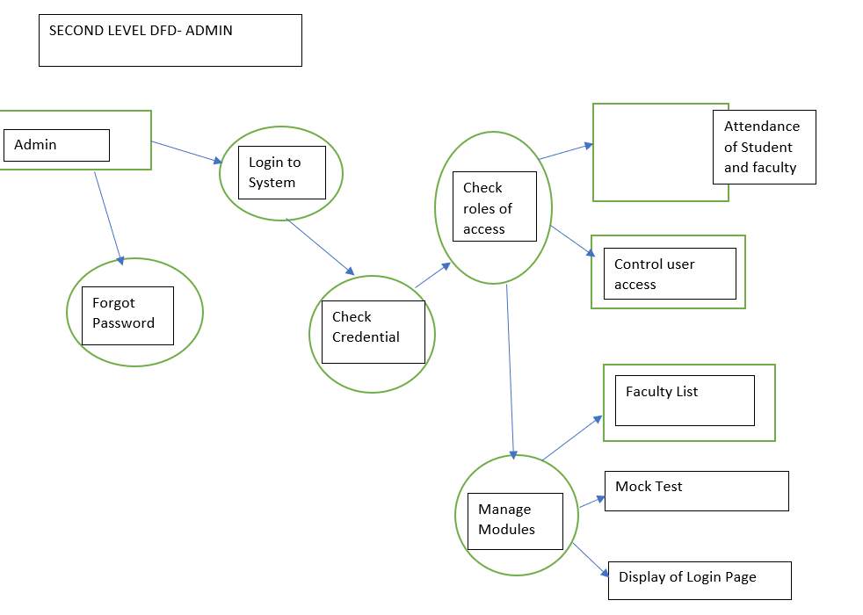

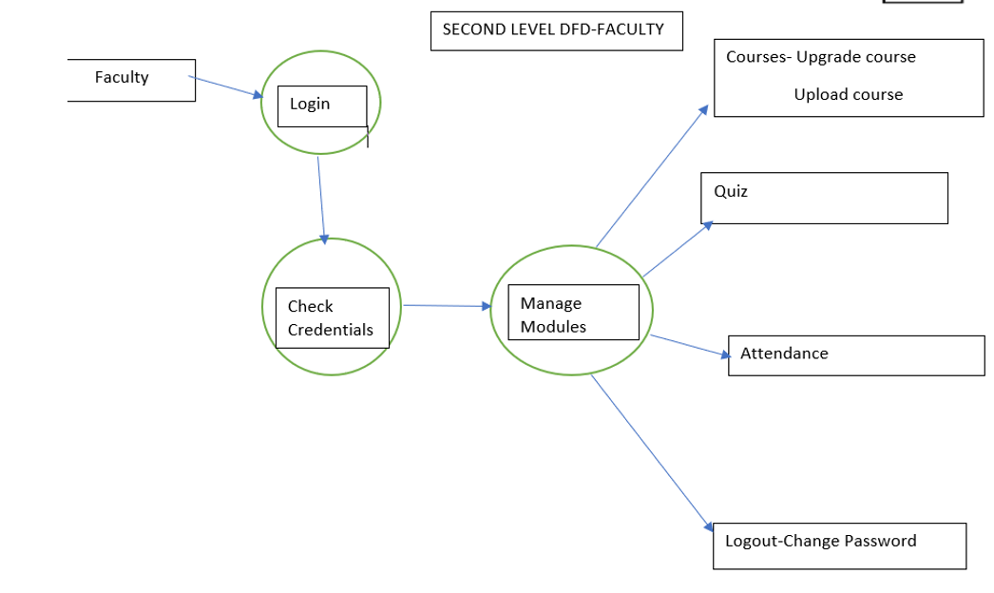

**CLASS DIAGRAM**

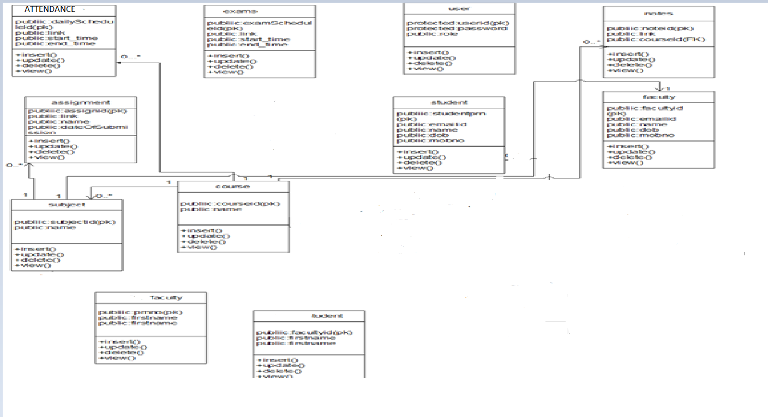

**Specification:**

* **The application will use Spring boot, React JS as main web technologies.**
* **My SQL is used as database technology.**
* **Since Coaching Institute Management System(CIMS)is a web-based application, internet connection must be established.**
* **The CIMS will be used on PCs and will function via internet or intranet in any web browser.**

**S/W and H/W Requirements:**

* Server Side:

* **Processor:** Intel® Xeon® processor 3500 series
* **HDD:** Minimum 500GB Disk Space
* **RAM:** Minimum 4GB
* **OS:** Windows 10
* **Database:** MySQL

* Client Side (minimum requirement):

* **Processor:** Intel Dual Core
* **HDD:** Minimum 80GB Disk Space
* **RAM:** Minimum 2GB
* **OS:** Windows 7

DATABASE TABLES

ADMIN

|  |  |  |  |  |  |
| --- | --- | --- | --- | --- | --- |
| Field | Type | Null | Key | Default | Extra |
| admin_id | int | NO | PRI | NULL | Auto increament |
| email | Varchar(50) | NO | UNI | NULL |  |
| Name | Varchar(50) | NO |  | NULL |  |
| Password  Role | Varchar(50)  Varchar(50) | YES  No |  | NULL  Null |  |

FACULTY

|  |  |  |  |  |  |
| --- | --- | --- | --- | --- | --- |
| Field | type | null | Key | default | Extra |
| Faculty_id | Int | No | Pri | Null | Auto increment |
| Address | Varchar(255) | Yes |  | Null |  |
| Course1 | Varchar(255) | Yes |  | Null |  |
| Course2 | Varchar(255) | Yes |  | Null |  |
| Course3 | Varchar(255) | Yes |  | Null |  |
| Email | Varchar(50) | No | Uni | Null |  |
| Name | Varchar(50) | No |  | Null |  |
| Password | Varchar(50) | Yes |  | Null |  |
| Role | Varchar(50) | No |  | Null |  |

STUDENT

|  |  |  |  |  |  |
| --- | --- | --- | --- | --- | --- |
| Field | Type | Null | Key | Default | Extra |
| Student_id | Int | No | Pri | Null | Auto_increment |
| Address | Varchar(255) | Yes |  | Null |  |
| Attendance | Int | No |  | Null |  |
| Course | Varchar(255) | Yes |  | Null |  |
| Email | Varchar(50) | No | Uni | Null |  |
| Name | Varchar(500 | No |  | Null |  |
| Password | Varchar(50) | Yes |  | Null |  |
| Role | Varchar(50) | No |  | Null |  |
|  |  |  |  |  |  |

COURSE

|  |  |  |  |  |  |
| --- | --- | --- | --- | --- | --- |
| Field | Type | Null | Key | Default | Extra |
| Course_id | Int | No | PRI | NULL | Auto_increment |
| Course_name | Varchar(255) | Yes | UNI | NULL |  |
| Course_fee | Int | No |  | NULL |  |
| Course_duration | double | no |  | NULL |  |

RECORDS

|  |  |  |  |  |  |
| --- | --- | --- | --- | --- | --- |
| Field | Type | Null | Key | Default | Extra |
| Record_id | Int | No | PRI | NULL | Auto_increment |
| Course | Varchar(255) | No |  | NULL |  |
| Link | Varchar(255) | No |  | NULL |  |
| subject | Varchar(255) | No |  | NULL |  |

TEST

|  |  |  |  |  |  |
| --- | --- | --- | --- | --- | --- |
| Field | Type | Null | Key | Default | Extra |
| Test_id | bigint | No | PRI | NULL | Auto_increment |
| Ac1 | Varchar(255) | No |  | NULL |  |
| course | Varchar(255) | Yes |  | NULL |  |